**Assignment 04**

**Decision Tree – Play Cricket**

Name: Puja Kawale

SJSUID: 012506156

Date: 10/09/2018

Decision Tree: Decision Tree Classifies the data in the form of tree structure. It will divide the dataset in smaller fragments with the inverted tree structure. The final result will be condition nodes with resulting leaf nodes. It caters both categorical and numerical data. The topmost node / best predictor node is called as root node. The process of breaking the root node to sub nodes is called as splitting. An intermediate sub node may also be refereed as decision node. Leaf nodes are the nodes who have no child nodes. The sections of decision tree are called as branches. The algorithms used to decide the best feature for prediction is ID3, Gini index and others.

GitHub Link: <https://github.com/pujakb/ML/tree/master/DecisionTree>

Screen shots of Play cricket Decision tree exercise including the calculations and hand drawn diagram:

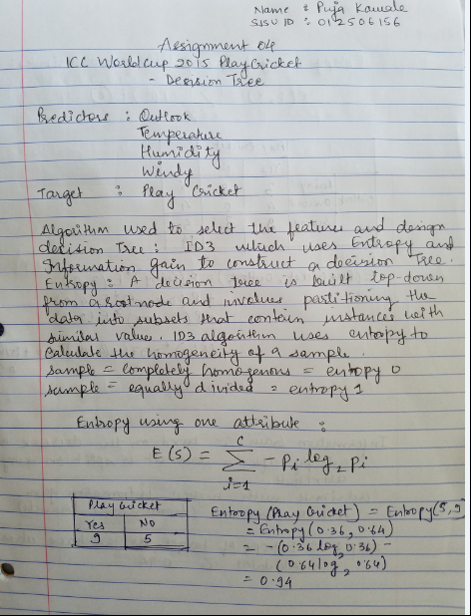

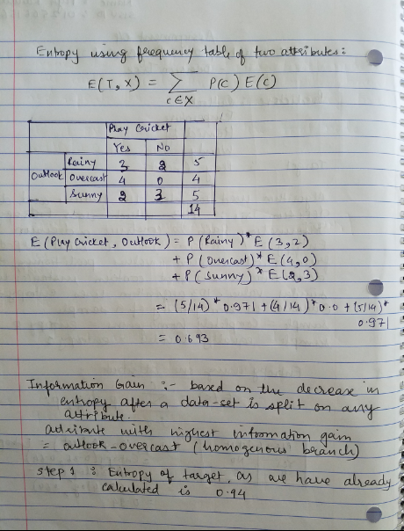

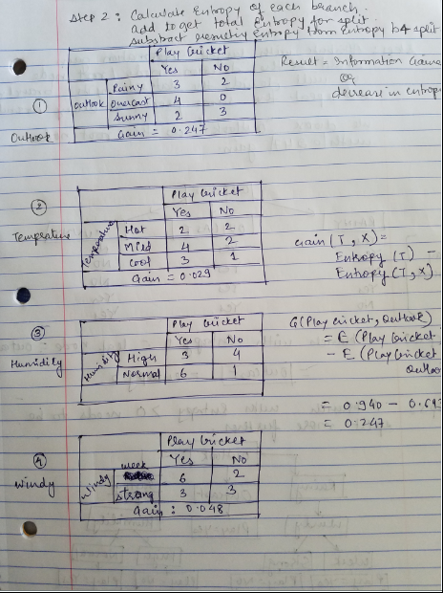

Outlook (gain) = 0.247

Temperature (Gain) = 0.029

Humidity(gain) = 0.152

Windy (gain) = 0.048

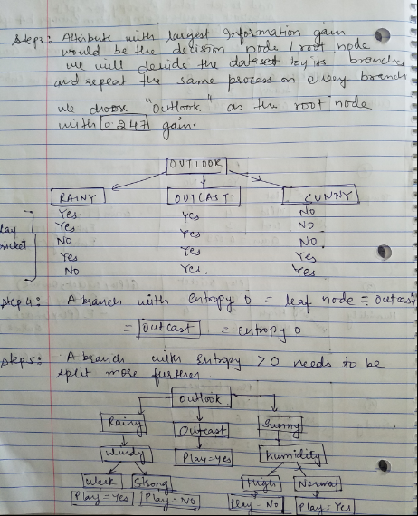

Thank you !!